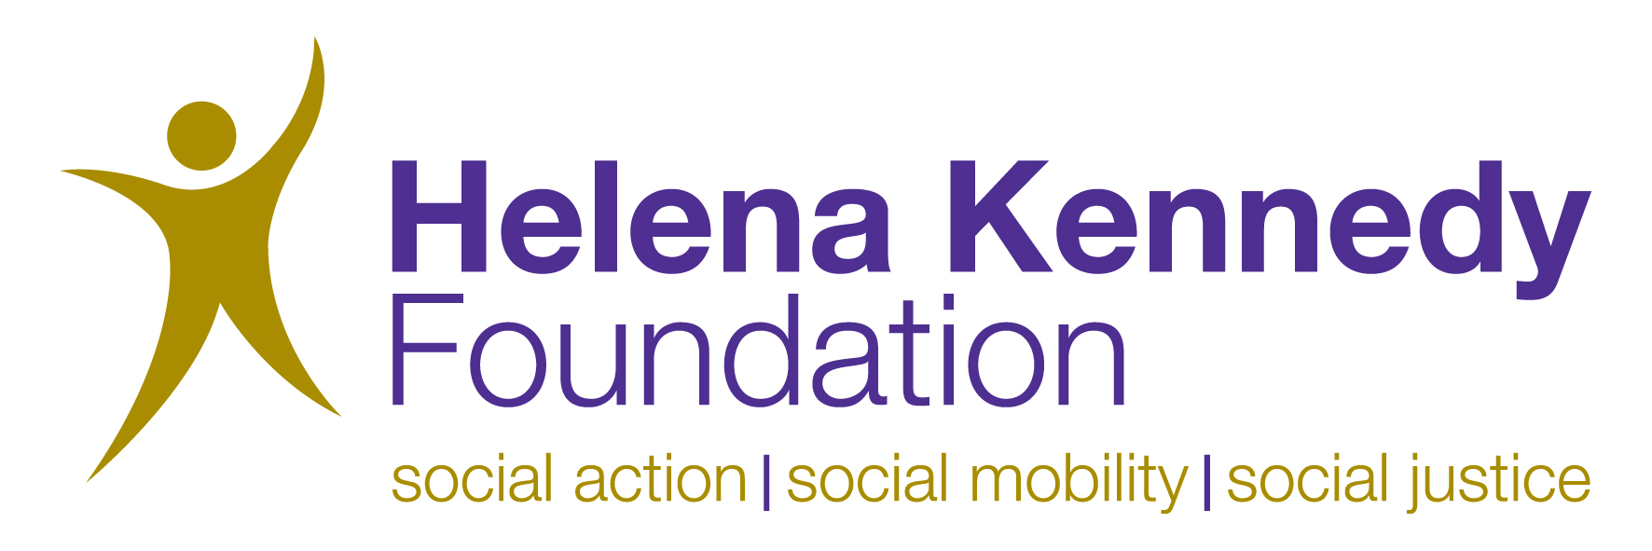

Article 26 Pilot Project – supporting Students Seeking Sanctuary to access higher education

Helena Kennedy Foundation
The Helena Kennedy Foundation is an independent social action charity established in 1998. The Foundation’s aim is to help increase social mobility by opening doors for some of the poorest and most deprived in our society. We encourage disadvantaged students to study for a university degree, get a job and make their mark in the world, providing them with access to support, mentoring and skills training programmes alongside internships, work shadowing opportunities and financial bursaries. By taking these actions we help promote greater social justice.

Article 26
Young people seeking sanctuary, whether they are separated from or living with their parents are some of the most vulnerable people in the UK. Article 26, a project of the Helena Kennedy Foundation, aims to make higher education a reality for as many of these young people as possible.

Pilot project
Article 26 is working in partnership with three universities; the University of Winchester, the University of Chichester and the University of Chester, to enable one young person seeking sanctuary to progress to each of the universities in 2010.
Successful applicants for the project will be provided with:
- A tuition fee-remitted place at the university until such time as their asylum claim is resolved
- A Personal Support Plan to enable the student to identify and overcome barriers to achievement on their degree programme
- Group support and training to cover topics including ‘Minimising the impact of Asylum Process on your higher education course’
- Further training and mentoring provided by the Helena Kennedy Foundation – which has over 12 years of experience of supporting students. Examples of training sessions include confidence building, interview skills, revision techniques, stress management and public speaking

Who can apply?
Students must be nominated by a College, School or Voluntary or Community Group, which must be prepared to support their application and provide a reference.
In order to apply for a place on the Article 26 pilot project students must be:
• Currently attending a school, college or community or voluntary group which is able and prepared to supply a reference for the student and support their application
• Aiming to start a first-time programme of higher education in the autumn of the year in which they are applying at the University of Winchester, University of Chester or University of Chichester and able to demonstrate that they have made an application to the university in question
- Able to provide evidence of their status in the UK and prepared to undergo assessment of their personal circumstances and suitability to undertake a degree

AND

• An asylum-seeker, or the partner or dependent of an asylum-seeker; or
• A person who has acquired settled status to live in the UK within the past 2 years, but has not completed 3 years of ordinary residence in the UK

How to apply
If you know a student who you think may be eligible, or you are a student seeking sanctuary who meets the above criteria, please contact the Article 26 Project Manager, Rebecca Murray on 0797 944 1848 or email article26@hkf.org.uk. to find out more and request an application pack.

Article 26
Helena Kennedy Foundation
The Mansion
Bletchley Park
Bletchley
Milton Keynes
MK3 6EB

0797 944 1848
article26@hkf.org.uk

